**[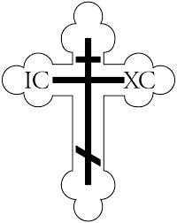](http://images.google.com/imgres?imgurl=http://www.ocf.org/OrthodoxPage/icons/clip/cross.gif&imgrefurl=http://www.ocf.org/OrthodoxPage/icons/clip_in.html&h=3300&w=2626&sz=45&tbnid=eRhzRH-TiucJ:&tbnh=149&tbnw=119&start=16&prev=/images?q=cross&hl=en&lr=&ie=UTF-8)St. Nicholas Orthodox Church**

**67 Saratoga St. Cohoes, NY 12047**

**Fr. Terenti Wasielewski, Rector**

**518-369-2430**

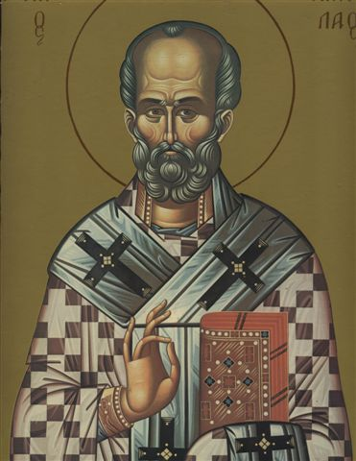

**http:saintnicholascohoes.org**

**August 2014**

**Dear Reverend Fathers and Church Members,**

**Glory to Jesus Christ! Glory forever!**

**The Parish of St. Nicholas in Cohoes, New York is celebrating their 100th anniversary this year. As part of the festivities, we invite you to our anniversary celebration which will be held on Columbus Day weekend, Saturday October 11th and Sunday, October 12th.**

**On Saturday morning October 11th at 9:30 a.m., a Divine Liturgy will be celebrated in memory of the founders and in honor of the members and benefactors of our church. At 3:30 pm in the church hall, we invite you to a Presentation of History of the Parish and tour of the church renovations and light meal followed by Great Vespers at 6:00 pm.**

**On Sunday morning October 12th at 9:00 a.m., we will process into church for a Hierarchical Divine Liturgy. A banquet will follow at 12 pm at Ukrainian Hall in Cohoes.**

**Attached is a flyer with the banquet menu, a reservation card for your selections as well as a flyer if you wish to sponsor a commemorative or memorial message. A centennial anniversary book with the church history will be published after the event which will include photographs from the 100th year celebration.**

**Please review the materials and consider being a part of our parish’s 100th year celebration.**

**With love in Christ,**

**Fr. Terenti Wasielewski Gregory Walko**

**Rector President, Parish Council**