**[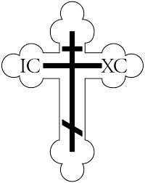](http://images.google.com/imgres?imgurl=http://www.ocf.org/OrthodoxPage/icons/clip/cross.gif&imgrefurl=http://www.ocf.org/OrthodoxPage/icons/clip_in.html&h=3300&w=2626&sz=45&tbnid=eRhzRH-TiucJ:&tbnh=149&tbnw=119&start=16&prev=/images?q=cross&hl=en&lr=&ie=UTF-8)St. Nicholas Orthodox Church**

**Centennial Book**

**A Centennial Book including our church history will be produced after our celebration in order to include pictures from the festivities. Please consider sponsoring a listing of congratulatory and/or memorial messages:**

**$150 Full page (8.5 x 11)**

**$75 half page (8.5 x 5.5)**

**$50 quarter page (4.25 x 2.75)**

**$20 Memorial Page Listing**

**Text and images can be forwarded to Fr. Terenti:**

**In print – send to St. Nicholas Church, 67 Saratoga St. Cohoes, 12047; send electronically – email:** [**wasiet@sage.edu**](mailto:wasiet@sage.edu)

