[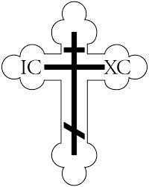](http://images.google.com/imgres?imgurl=http://www.ocf.org/OrthodoxPage/icons/clip/cross.gif&imgrefurl=http://www.ocf.org/OrthodoxPage/icons/clip_in.html&h=3300&w=2626&sz=45&tbnid=eRhzRH-TiucJ:&tbnh=149&tbnw=119&start=16&prev=/images?q=cross&hl=en&lr=&ie=UTF-8)**St. Nicholas Orthodox Church**

**Icon Project**

**St. Nicholas Church has been working on refurbishing the walls with new icons. Written in the Macedonian style by a renowned iconographer, Aftimios Stoja who is originally from Albania, Phase I focused on writing new icons for the side walls. This project is almost complete. During Phase II which will take place in 2015, the icons on the iconostasis will be replaced. All icons for Phase II have been purchased.**

**Phase III will be done in 2016 with the placing of the traditional Pantocrator and the Platitera on the ceiling. Donations will be accepted for this project or any other icon project. If you are interested in contributing to our 100th anniversary icon fund, contact Fr. Terenti at St. Nicholas Church, 67 Saratoga St., Cohoes, NY 12047; by email:** [**wasiet@sage.edu**](mailto:wasiet@sage.edu)**; or by phone: 518-369-2430.**

